FL-01: Draw the Path: Portfolio Sitemap
Princess Adekola

1. Sitemap Sketch

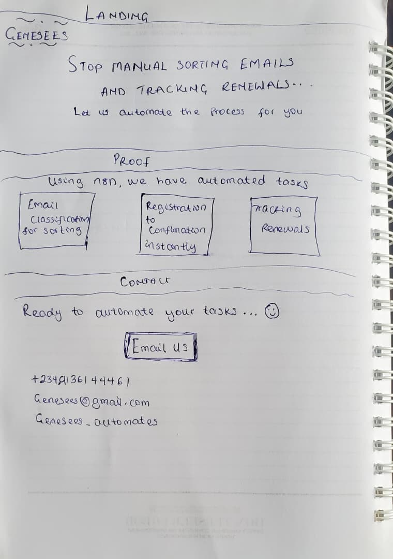

2. Claude Project Setup
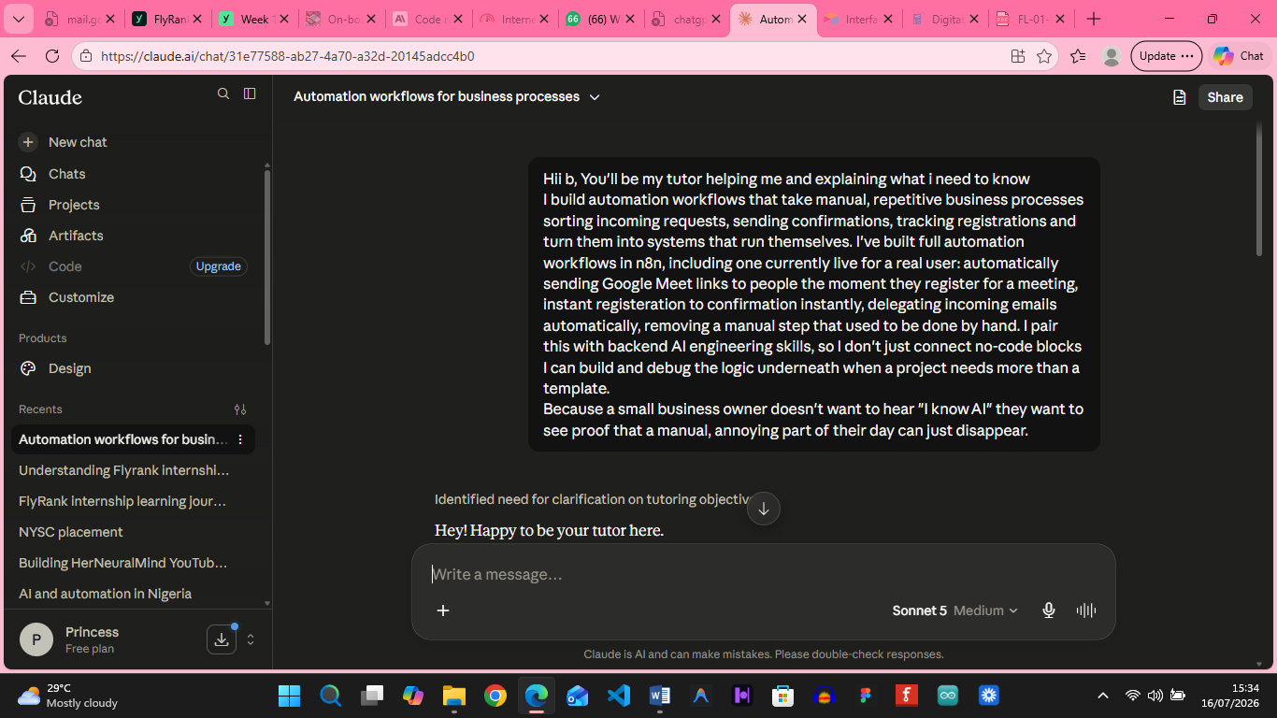

3. Pressure-test prompt + output

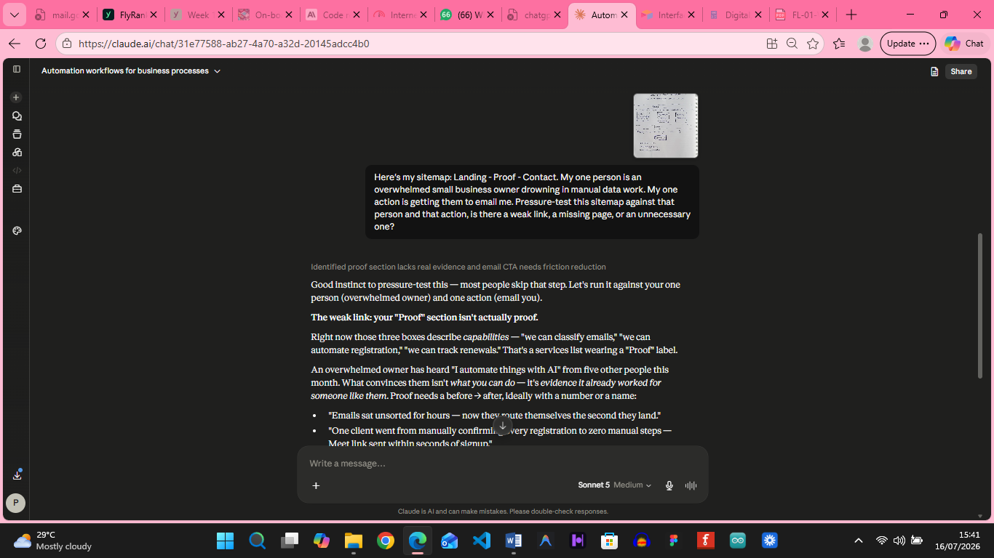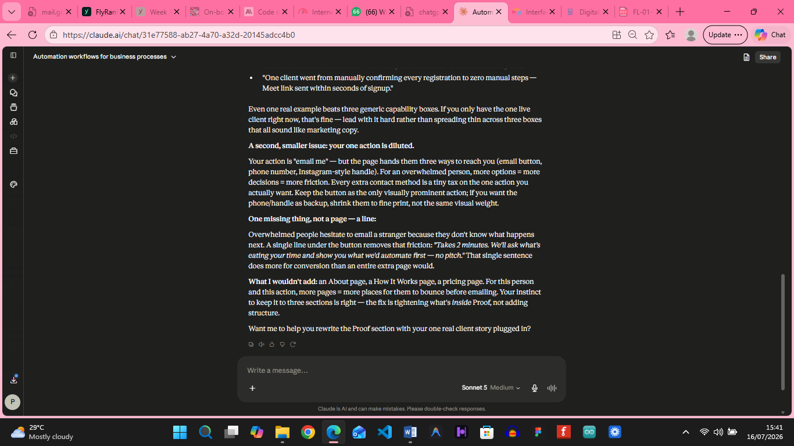

What I’ll change:

I’ll ensure that the proofs are real world projects and will use only one action ‘email us’ and not bombard the person with too much obvious options but keep them as smaller texts

